

WQ-

SPECIFICATION FOR DRY WALL, AIRCONDITION INSTALLATION AND FIREPROOFING SERVER CABINETS AT BOTHONGO PLAZA EAST BUILDING, PRETORIA

SPECIFICATION FOR DRY WALL, AIRCONDITION INSTALLATION AND FIREPROOFING SERVER CABINETS AT BOTHONGO PLAZA EAST BUILDING, PRETORIA

- BACKGROUND

In order to deliver against its mandate the Department of Water And Sanitation (DWS) need to improve its efficiency, effectiveness, security and information reliability to deliver more – better, faster, and cost effectively with the relevant controls in terms of best practice and good governance. A key element in this drive towards effectiveness and efficiency is the use of ICT that within the DWS environment nationally.

The cabinets connecting users on the different floors are not ringfenced and this poses a huge security risk regarding both physical security and data security. These cabinets need to be enclosed to ensure that no unauthorized access takes place and also that the equipment within the cabinets are kept safe.

Also the server room needs to be fireproofed and the door also needs to be changed to a fireproof door.

- REQUIRED

QUOTE ON THE FOLLOWING ITEM (S) / SERVICES
NO. | DESCRIPTION | QUANTITY OF ITEM (S) | Images
1. | 11th Floor Cabinet revamp  - Light and switch installation  - Fireproof the existing room  - Installation of Biometric access on the outside  - Installation of the infrared door release on the inside  - Supply and Installation of 9000 BTU air conditioning (indoor and outdoor unit)  - 3 Years preventative maintenance on the Air conditioning  Room Measurements: 235 x 166 cm Height : 250cm | 01 EACH | - infrared door release  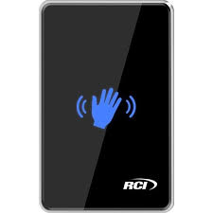  - Biometric access on the outside, Description of the Device: SpeedFace-V5L[P] Face, Palm and Fingerprint Recognition Device  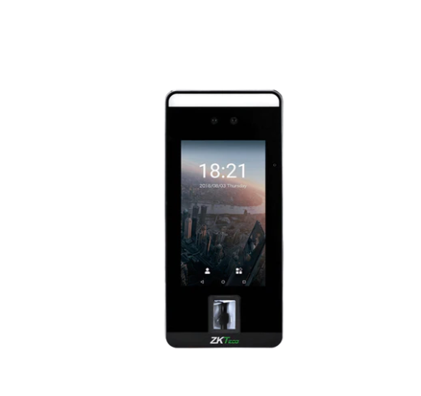  - 9000 BTU Air conditioner  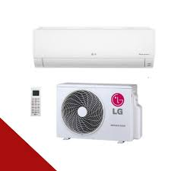
2. | 14 the Floor Server Room  - Fireproof the whole room including the ceiling  - Supply and Installation of a fireproof door and its Heavy duty Closer including the certificate  - Supply and installation of Sliding Glass door including frosting  - Provision and installation of security door with magnetic lock  - The Security door to be linked with the current biometric system  - Room Measurements  Room: 280.5 x 392 cm Height : 247 cm | 01 EACH | - Fireproof door with Certificate  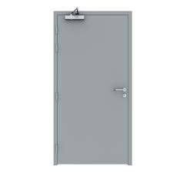  - Sliding door and Frosting  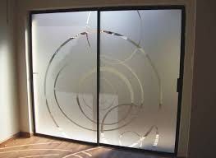  - Security door  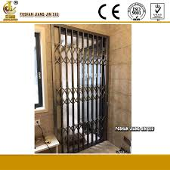
3. | 15th Floor  - Light and switch Supply and installation  - Supply and install the partition to enclose the cabinet to attain the following room measurement:  214.5 cm x 307.5 cm. The walls must be raised to the ceiling.  - Fireproof the new area  - Supply and Installation of a fireproof door.  - Supply and installation of a Heavy duty door closer.  - Installation of Biometric access on the outside  - Installation of the infrared door release on the inside  - Supply and Installation of 9000 BTU air conditioning (indoor and outdoor unit)  - 3 Years preventative maintenance on the Air conditioning  - New Partition to be pasted with a wallpaper same as the existing one | 01 EACH | - infrared door release  - Fireproof door with Certificate  - Biometric access on the outside, Description of the Device: SpeedFace-V5L[P] Face, Palm and Fingerprint Recognition Device  - 9000 BTU Air conditioner
4. | 16th Floor  - Light and switch Supply and installation  - Supply and install the partition to enclose the cabinet to attain the following room measurement:  191.5 x 170 cm. The walls must be raised to the ceiling.  - Fireproof the new area  - Supply and Installation of a fireproof door.  - Supply and installation of a Heavy duty door closer.  - Installation of Biometric access on the outside  - Installation of the infrared door release on the inside  - Supply and Installation of 9000 BTU air conditioning (indoor and outdoor unit)  - 3 Years preventative maintenance on the Air conditioning  - New Partition to be pasted with a wallpaper same as the existing one | 01 EACH | - infrared door release  - Fireproof door with Certificate  - Biometric access on the outside, Description of the Device: SpeedFace-V5L[P] Face, Palm and Fingerprint Recognition Device  - 9000 BTU Air conditioner
5. | 16th Floor HR Offices Dermacation | 01 EACH | Please check the attached annexure
6. | 14th Floor Registry | 01 EACH | Please check the attached annexure

- DELIVERY

The bid must be submitted to the Department of Water and Sanitation: Gauteng Provincial Office in the tender box situated at the 15th floor, Bothongo Plaza East Building, 285 Francis
Baard Street, Pretoria. The successful bidder will commence the work immediately after the receipt of Government order.

- CLOSING DATE AND TIME

Date:
Time:

- SITE VISIT

There will be a compulsory site visit

- CONTACT DETAILS
Please contact the Department for more details:
Full name : Patrick Mabasa
Telephone : 012 392 1530
E-Mail : mabasap@dws.gov.za
Signature :
Date :

